**Usage Manual**

The New Relic Bot will notify alerts & deployment notifications of your applications monitored by user New Relic account. To configure New Relic integration for a Teamchat group write keyword “help” in your group. The New Relic Bot will post a link as a chatlet. The user need to create a new webhook from his New Relic account settings and paste the link as webhook URL.

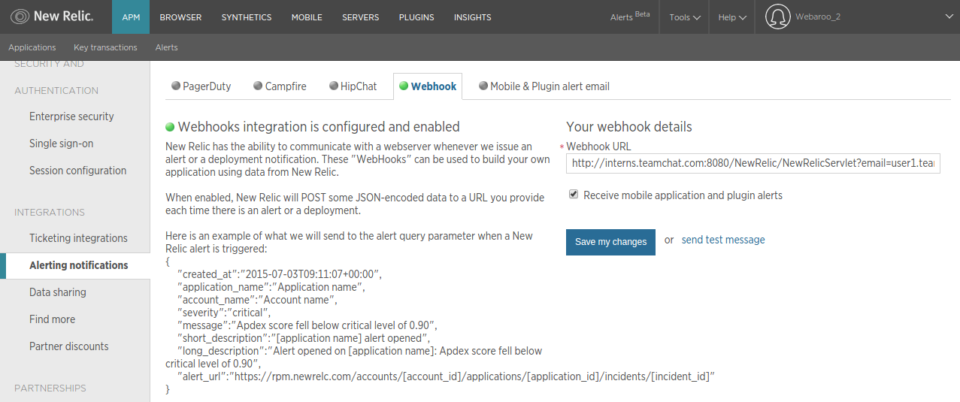

Once this is done, click on new alert policies fill in the details to create new alert channel.

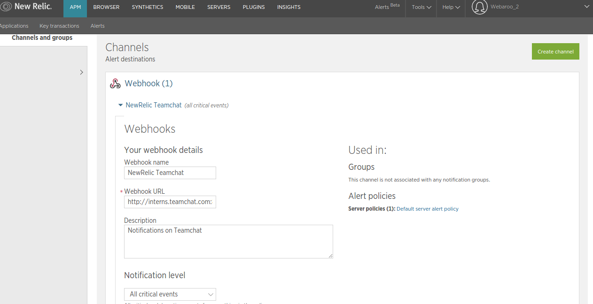

The New Relic bot will send alerts and notification on the teamchat group here on.